**Working Groups – Updates**

**September 2022**

**Culture**

Members of the working group have been away or on annual leave and so this group has struggled to get in touch in the past few months. This group intends to meet once everyone is back from leave.

**Staff Recruitment, Development, and Progression**

Because Lea is leaving us, this group has recruited two additional members: Barbara Hannigan and Sonia Bishop, and Redmond has reached out to Michelle Le Good to see if she would be willing to join the group. This working group will plan to meet over the next few weeks in order to move action items forward.

**Student Recruitment and Support**

Held a working group meeting on 01 September. In that meeting, they went through the following key points:

1. Reviewed representation on sub-committee.

Presently we have only two student representatives and both are UGs.

*Action*: Need to recruit new members from PCC, MSc, taught doctorate and PhD student groups to ensure adequate representation of student voices in the recruitment and career support activities of the EDI committee.

2. Reviewed preliminary findings from Student Survey 2022.

*Action*: Further analyses to be conducted and findings to be more formally written up and circulated to Kristin and broader EDI Committee

*Action*: Edits to Student Survey 2023 to be finalised by year end 2022 and circulated to students early in HT 2023 to avoid clashes with end of term assessment period.

3. Discussed sub-group aim to ‘Conduct and analyse survey of UG students from several universities examining in detail their attitudes toward engaging in PG studies in Psychology and their reasons for/against electing to pursue PG studies’.

*Action*: Contact EDI colleagues in other psychology schools in other universities to discuss potential to collaborate on this piece of data collection/research.

4. Discussed sub-group aim to ‘Report on secondary student survey on studying Psychology submitted to EDIC and published on the School EDI webpage’. It was initially proposed that this may be a FYP. However, the advantages of conducted it as a funded project with designated RA was highlighted.

*Action*: Keep alert to small-scale funding opportunities advertised over the coming months.

**Governance, Policies, and Data**

Kristin and Clare met on 27 July to discuss the plan of action for this working group, and then we met as a whole working group on 23 August to discuss each of the actions. Kristin met with HoS Sven on 08 August to discuss EDI generally and specifically policies around workload allocation and data collection and accessibility in the School.

Kristin wrote to Meghan Wallace in HR about access to data and records. Meghan responded with the following (her responses in blue):

1. Is there any staff exit survey at Trinity? That is, when staff leave, do they complete an interview or survey with HR directly about their reasons for leaving? If so, would it be possible to get access to this data or to add to it for those leaving from the SoP, to ask about potential gender, race and ethnicity, or disability-related issues that have impacted their decision to leave?

Currently, there is not a staff exit survey across the College. I believe some Schools/unit may conduct their own exit surveys/meetings with staff at a local level.

1. What is the shortlisting model for research and academic staff in College at the moment? Is this shortlisting blinded (by gender, etc)? Are there any proposals ongoing to bring in blinded shortlisting for positions?

For Academic staff (and admin/professional/technical staff) we follow the TCD Recruitment Policy [procedure07-recruitmentpolicy.pdf (tcd.ie)](https://www.tcd.ie/hr/assets/pdf/procedure07-recruitmentpolicy.pdf). In the selection committee section of the policy it outlines the gender representation and other guidance around best practice.

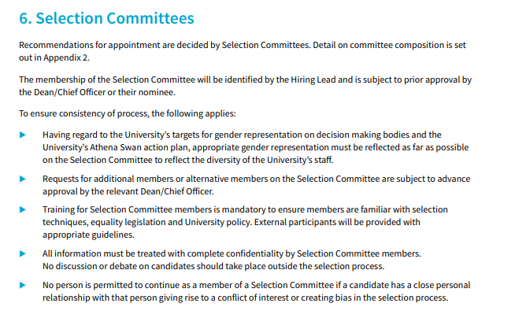

I am unaware if there is any discussion around blinded short-listing, I am copying in the Head of Partnering and the Head of Talent who may be able to shed some light on this query.

In terms of recruitment of research staff, the PIs/Grant Holders are responsible for their own recruitment of research staff. The Recruitment Partner for FAHSS can assist with advertising the post. The Researchers are encouraged to follow best practices around advertising, short-listing and interviewing. A nomination process is then used to hire the incumbent to the University.

1. I hear that there will be a new workload allocation brought in, perhaps this autumn. Is there any proposal for EDI or other committees to weigh in on this model before it is implemented? Will the EDI committee be able to access the workload allocation data and gender for those employed in the SoP so that we can evaluate this in our Athena Swan submissions?

I believe this is being discussed at a College level. My understanding from the Faculty Dean is that this was very much in the early phases. I will raise this query to her and come back to you with further updates.

1. One of our actions is to “compile and monitor on an annual basis data on the number of research staff on contracts over short and longer terms.” Would it be possible to obtain this information as well as gender information from HR about research staff?

I will consult with my colleagues in HR to see what is possible in terms of statistics for contracts of research staff and whether tracking of gender may be available in terms of statistics. Susan and Fidelma -appreciate any updates you may have on this.

1. We also want to evaluate who applies for and ‘gets through’ the merit bar by gender. Would it be possible to get information from HR on the gender breakdown for SoP applications to go above the merit bar and their success rate? Similarly, would it be possible to get a gender breakdown of the proportion of faculty by gender who are appointed above and below the merit bar when first hired?

I will consult with my colleagues as to what information is data is available in terms of gender for [Junior Academic Progression](https://www.tcd.ie/hr/spr/promotion-progression/jun-aca-progression.php). My understanding is the majority of Academics that we hire now in the Faculty of Arts, Humanities and Social Sciences are hired on tenure track contracts [Tenure Track Reviews - Human Resources - Trinity College Dublin (tcd.ie)](https://www.tcd.ie/hr/spr/tenure-track/index.php) .

Fidelma Haffey also responded to question 2 above, saying: “There is no discussion at present to introduce shortlisting blind for academic staff (by gender, etc).” and question 5 saying, “I will discuss this request with Megan.”

In addition, Kristin wrote to Sam in College EDI, with the following (Sam’s responses in red):

1. One of our actions is to “Conduct a detailed review of the distribution of contracts and sources of funding across all academic staff levels in the School, assessing evidence for gender-balance.” Presumably somewhere in College this data is already collected. Do you know how we can get access to it? – We have information on academic staff and contracts across different grades, we do also have information on the project that staff are funded from, what level of detail do you need for this? Would you need the exact project/account code or just whether staff member is charged to a research or departmental account? I am on annual leave from today until next Wednesday but when I’m back I can begin to compile this for the last 5 years and send it on you to review.
2. Similarly, we are looking to monitor pay levels for female and male staff to compare for gender differences. Do you know where in College we can access this information? – A lot of work has been done on this at institutional level. We have a report on gender pay differences within TCD coming out around December, I will try find out if this will enable us to get the information at School level.

Finally, you’d said that a new workload allocation model would be mooted from October. Is there any information about that model that I can share with the School of Psychology EDI committee? – The committee have been on a break over the summer, so I’m hoping there is another meeting soon. I will keep you updated on this.

Kristin then followed up on this with Sam but has not heard back, so followed up again.

**Communications and Marketing**

Michael and Karen held a meeting in end August to discuss each of the actions. The working group met with Kristin on 05 September to discuss how this working group could address the different actions associated with this WG, where they should try to get data for these, etc. This working group suggested a change to the website to specifically list the School Exec members and Ensar has made this change to the SoP site.